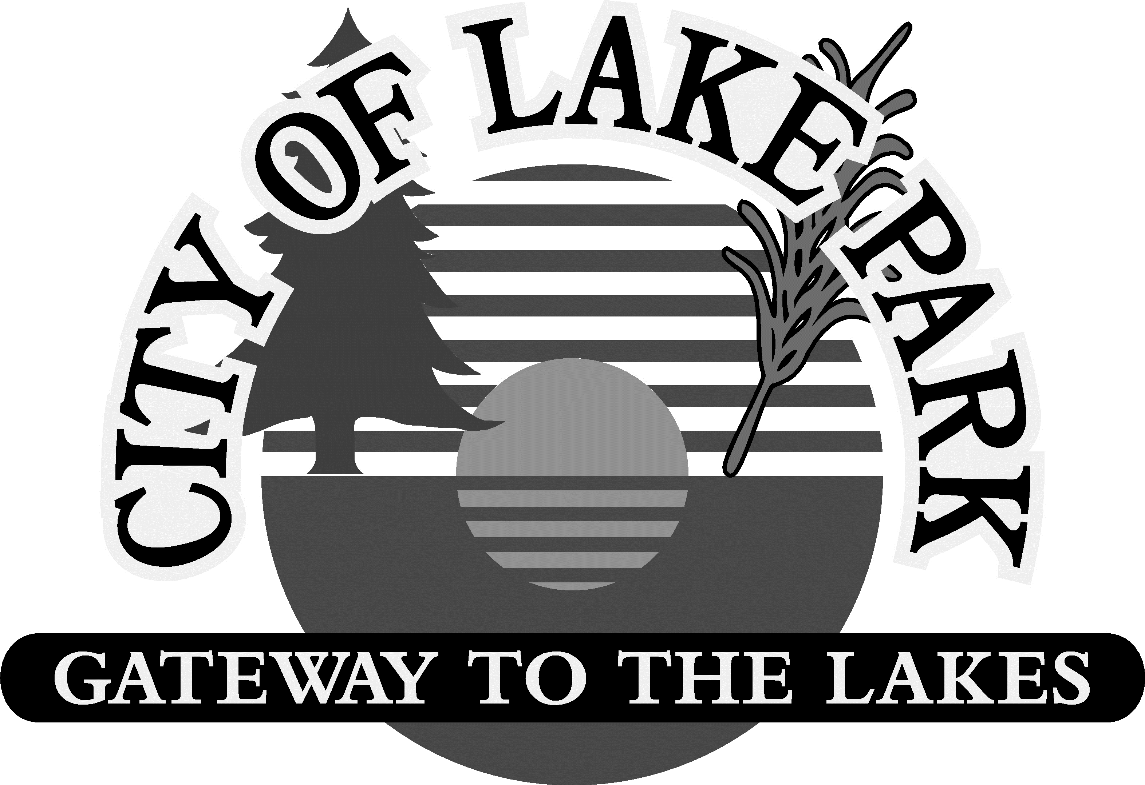
LAKE PARK CITY COUNCIL
CAPITAL FINANCIAL MINUTES
2032 2nd Street, Lake Park, MN 56554
October 9th, 2023 – 5:30 pm

- CALL TO ORDER and ROLL CALL
  - Present: John Beaudine, Tammy Charbonneau, Kayla Mayer, Sarah Mikkelsen, Jason Murray, Carla Nelson, and Aaron Wittrock
  - Not Present: Jon Anderson and Britney Ronning

- JASON MURRAY, David Drone Associates
  - David Drown Associates, Inc. Public Finance Advisors conducted a capital financial planning workshop with the City Council. The purpose of the workshop was to assist the City with developing an understanding of the City’s financial condition and to provide a tool to evaluate the feasibility of future capital improvement projects and purchases. Jason Murray summarized the major findings and conclusions reached at the presentation.

- ADJOURNMENT
M/S/CU: Wittrock/Beaudine to adjourn meeting at 6:00 p.m.

